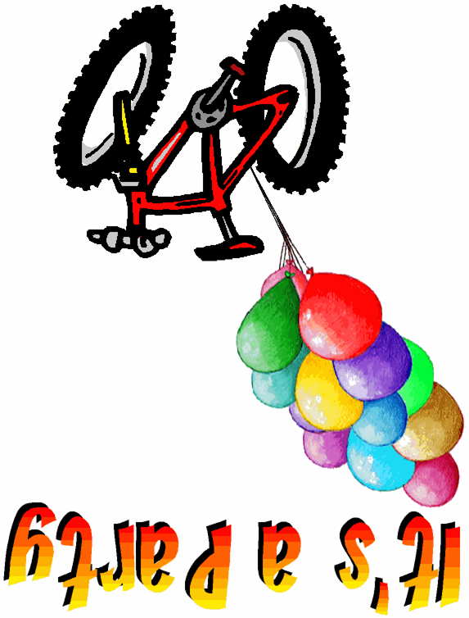
Please come and help John celebrate his birthday!

Date: Sat., Jan. 23, 2003
Time: 1pm to 3pm
Location: Cactus Park BMX
R.S.V.P. Mary Smith
By 1/23/03 858-555-1212

Bring your bike, helmet and you must wear long sleeved shirt and long pants. We’ll have food and drinks and lots of fun riding the BMX race track !

(Parents, please sign enclosed safety waiver.)
Without it & the proper attire riders will not be allowed to ride the track.

Visit Track website at www.cactusparkbmx.com for more information.

Cactus Park BMX:

10610 Ashwood St,
Lakeside, CA 92040

Directions to the Track
from Interstate 8 take Highway 67 North,
Turn right on Mapleview,
Turn left on Ashwood,
Cactus Park Track is on your left about 1 mile, next to the baseball fields

