Please join us for
John Smith’s Birthday Party

Sunday, January23rd
From 1 to 3:30 p.m.

At Cactus Park BMX
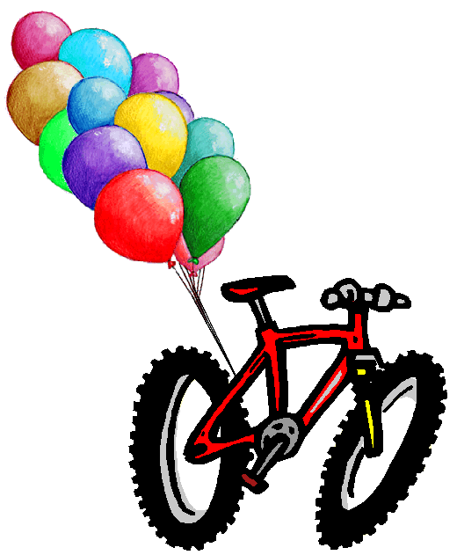

Bring your bike and helmet !

You must also wear long pants and a long-sleeve shirt.
We’ll have food and drinks and lots of fun riding the BMX race track!
(Parents will need to sign the enclosed safety waiver)
without it & the proper attire riders will not be allowed to ride the track

R.S.V.P by January 3rd
to Mary Smith at 858-555-1212

Directions and Cactus Park BMX information:

Cactus Park BMX
10610 Ashwood St, Lakeside, CA 92040
Directions to the Track
from Interstate 8 take Highway 67 North,
Turn right on Mapleview,
Turn left on Ashwood,
Cactus Park Track is on your left about 1 mile,
next to the baseball fields

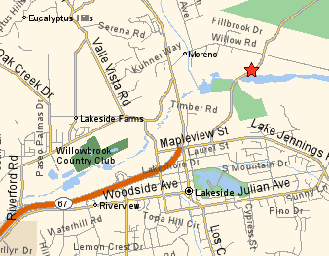

For More information go to www.cactusparkbmx.com

